SECTION 2 Political Revolutions:
Through much of history, monarchs ruled with the support of other members of society’s privileged classes. Most of the world’s peoples accepted that state of affairs—even some of the Enlightenment thinkers who put forward radical ideas about government and people’s natural rights. Starting in the late 1700s, however, radical ideas became reality. Political revolutions began to replace rule by a monarch with rule “by the people.” Of these, the American Revolution was the first.
The American Revolution A political revolution is a seizure of government by people intent on replacing the existing political system. It is something that comes about over time, as various forces gradually build to an explosion. In the case of the American colonies, the path to revolution began in 1763, at the end of another conflict, the French and Indian War.
Before then, Britain had given its 13 North American colonies substantial freedom. The king and Parliament had other things to worry about, namely defending against its rivals France and Spain. The French and Indian War, known in Europe as the Seven Years’ War, was just the latest in a series of costly international conflicts. Britain’s victory in that war ousted France from North America and gave British leaders time to focus on problems with their Atlantic coast colonies.
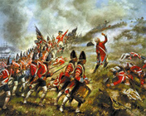
Click to read caption
One issue involved control. The Americans enjoyed considerable self-government and economic freedom. Britain moved to exert tighter central authority over the colonies. Another issue involved money. The French and Indian War had drained Britain’s treasury. To pay for the ongoing defense of the colonies, the British levied a series of taxes on Americans. Many colonists, having no direct link to Parliament, decried this “taxation without representation.” Mounting resistance to British policies ultimately led to the revolution.
The Americans had no reason to believe that they could defeat Britain, the strongest military power in the world. They endured several humiliating routs before victories at Trenton and Saratoga raised their spirits. The latter victory persuaded France to support General George Washington and his Continental Army with troops, supplies, and warships. The Spanish and Dutch also helped by keeping British naval forces busy in Europe. The British surrender at Yorktown came after a French blockade of the Virginia coast helped American ground troops trap Britain’s main army.
The Declaration of Independence listed numerous reasons for American separation from Britain. But they all came down to issues of freedom and liberty. As Patrick Henry famously said, “Give me liberty or give me death!” The desire for freedom and liberty also played an important role in the Federal Convention that followed the war, in 1787.
The resulting United States Constitution, and the Bill of Rights attached to it, created a novel form of government. It was a democracy based on principles of republicanism—separation of powers and representation of the people through their elected officials. Republicanism would also emerge as a driving force of the French Revolution.
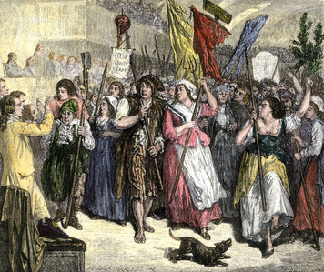
Click to read caption
The French Revolution A French officer, the Marquis de Lafayette, led the American army that trapped the British near Yorktown. After returning to France, he played a key role in the French Revolution. That revolution began in 1789, triggered by a financial crisis. Mounting debt resulting from continual warfare, including support for the American Revolution, threatened to bankrupt France.
To resolve the crisis, the king called a rare meeting of the Estates-General, a representative assembly consisting of the three French “estates,” or classes. During the meeting, the common people, known as the Third Estate, took over. These educated, working-class representatives demanded political, economic, and social rights denied them by the two privileged classes—the nobles and the clergy.
Some nobles, such as Lafayette, worked with the Third Estate. Lafayette drafted the Declaration of the Rights of Man and the Citizen, a core statement of French revolutionary principles. Like the founding political documents of the United States, this Declaration reflected a liberal philosophy. Liberalism favors individual political and economic freedom as well as equality. The demands of the Third Estate echoed through the streets of Paris and soon took the form of a people’s uprising. Violence spread to the countryside, where peasants attacked their landlords and destroyed property.
France’s neighbors feared that their own citizens might rise up and overturn their privileged classes. They also feared the French army, and with good reason. In 1792, French forces attacked Austria and then invaded Italy. By the end of the next year, France had enlisted more than a million new soldiers.
In 1799, the army’s leader, Napoleon Bonaparte, took part in a coup d’état that effectively ended the French Revolution. But warfare did not cease. After crowning himself emperor, Napoleon led a French army of conquest that dominated much of Europe by 1806.
The French Revolution had taken a very different track from the American Revolution. Its leaders went from establishing a limited constitutional monarchy to executing the king and creating a republic. At least 15,000 more enemies of the revolution, including several of its former leaders, were executed during a Reign of Terror from 1793 to 1794. The revolution was a radical attack on old institutions aimed at bringing about a new and better society. It altered people’s ideas of what a political revolution could do. It also inspired other peoples to seek political liberty by overthrowing absolute rulers and societal restraints.
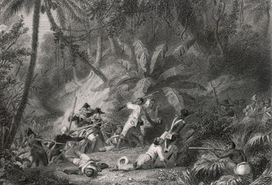
Click to read caption
Latin American Independence Movements In 1791, inspired by the French Revolution, slaves in the French colony of Saint-Domingue revolted. Saint-Domingue was a sugar- and coffee-producing colony on the Caribbean island of Hispaniola. A free black man, Toussaint L’Ouverture, joined the rebels in what became known as the Haitian Revolution. He helped lead them to victory and independence from France. Their struggle, which lasted until 1804, greatly altered the social order in the former colony, which they renamed Haiti.
Napoleon’s invasion of Portugal in 1807 and Spain in 1808 sparked unrest in much of the rest of Latin America. With ties to their home country severed, some Spanish colonists began devising their own, separate governments. Conflict broke out between patriots, who sought independence, and royalists, who opposed splitting with Spain.
The patriots tended to be Creoles, American-born descendants of Spanish settlers. They read Enlightenment authors and were inspired by the ideals of liberty and republicanism that came out of the American Revolution. The royalists were mainly peninsulares, or Spanish-born colonists whose natural loyalty was to Spain.
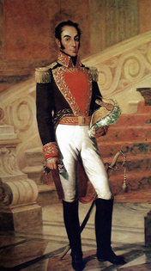
Click to read caption
Creole resistance to Spanish power went back to the late 1700s. Spain had then taken steps to regain control of Spanish America, much as the British had tried to reassert their authority over their North American colonies. They created new administrative units and placed peninsulares, not Creoles, in charge. They levied new taxes and took over parts of the economy. The Creoles resented these and other Spanish policies aimed at centralizing control.
The struggle for independence began in earnest in Buenos Aires, a city in present-day Argentina, when Creoles took political control and held on to it. That same year in Venezuela, patriots forced the Spanish governor to leave. But royalist forces fought back. Over the next several years, control of Venezuela moved back and forth between the opposing sides.
During the same period, two patriot armies developed in South America. Venezuelan Simón Bolívar led the Army of the North, which relied at first on Haitian weapons and money and foreign troops. José Francisco de San Martín led the southern army, the Army of the Andes. Region by region, the patriot armies overcame royalist resistance.
In Mexico, the independence movement began in 1810 with an explosion of violence against authority. Loyalist forces regained control by capturing and executing the revolution’s leaders. In 1821, after a shift in Spain toward liberalism, royalists and rebels worked together to produce a declaration of independence. By 1826, the independence movement had succeeded in wresting all of Spanish America from Spain, with the exception of two islands, Cuba and Puerto Rico.
Brazil achieved independence from Portugal without a violent upheaval. Social tensions existed, but between the dominant white people and the vastly larger population of enslaved Africans. The whites, fearing a slave revolt like the one in Haiti, relied on Portugal for protection. They stayed loyal in spite of policies that they disliked. In 1808, forced out of their homeland by Napoleon, the exiled Portuguese royal family settled in Brazil along with 10,000 or more supporters. They made Brazil the administrative center of the Portuguese empire. When the emperor returned to Portugal, he left his son behind to govern Brazil. In 1822, the new ruler declared Brazil independent.
SECTION 3 Nationalism and Nation-states:
The peoples of the new Latin American states showed great pride in their country. Pride is one common aspect of nationalism. People’s loyalty to their family or local leader expands into something bigger, encompassing an entire nation. In France, Napoleon had tapped that spirit of nationalism to form a massive volunteer army. As the army overran much of Europe, nationalism spread with it. In some places, it arose in the form of an “us-against-them” response to foreign invasion. In other places, it resulted from admiration of the French system.
Nationalism had two main effects. It stimulated the breakup of multinational empires. It also helped create nation-states by unifying people of the same ethnic origin living in separate states.
The Revolutions of 1848 A concerted effort by a group of European states stopped Napoleon in 1815 and restored France’s monarchy. Nevertheless, republicanism survived. It made a strong comeback in the Revolutions of 1848. These uprisings resulted from growing demands across Europe for political liberalization and social and economic reform.
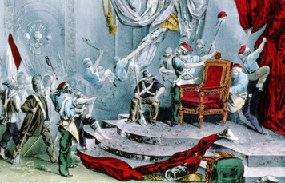
One of the first revolts occurred in Paris, France. There the government used military force to stifle street protests. Its inability to end the demonstrations or suppress the violence weakened leaders’ authority. Around that time, protests broke out in other major cities in Austria, Germany, and Italy. Revolution threatened to engulf Europe. To avoid that, several monarchs hastily promised reforms. Some leaders stepped down, and new constitutions were created. No great political shifts came directly out of the Revolutions of 1848. The uprisings, however, gave a boost to nationalist movements that, in time, produced several new nation-states.
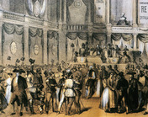
Italy Napoleon had invaded Italy in 1796. At the time, the Italian peninsula contained a mix of independent states and states ruled by Spain, Austria, and the Roman Catholic pope. The French invasion set off efforts to overthrow absolute rule. Napoleon wanted to centralize his rule of Italy as a unified republic. He told Italians, “You have only particular laws and you need general laws. Your people have only local customs and it is necessary that you acquire national habits.” In 1815, however, France lost its claim on Italy.
During the Revolutions of 1848, nationalists in Italy were still fighting for greater freedoms and political unity. In the years that followed, the Kingdom of Sardinia took the lead. With France as an ally, it waged a successful war against Austria. Sardinia won some territory as a result. It then began annexing additional states in north and central Italy. In each state, citizens were allowed to vote whether or not to accept the Sardinian takeover. Sardinia also supported a successful armed invasion of southern Italy. Nationalists finally achieved unification in 1861 with the formation of the Kingdom of Italy. Sardinia’s ruler became Italy’s king.
Germany As in Italy, the French Revolution had a strong impact on the process of German unification. Napoleon had destroyed the Holy Roman Empire when he conquered much of Europe. After Napoleon’s defeat, a gathering of European states at the Congress of Vienna in 1815 replaced the empire with a German Confederation of 39 states. Nationalists worked to unify those states.
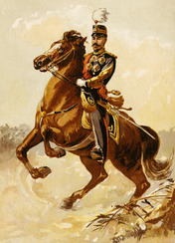
The demands of industrialization played a role in unifying Germany. In 1834, German states joined together in an economic alliance. This took Germans farther down the path to political unification. However, they did not actually achieve it until a series of wars led to the formation of the German Empire in 1871.
Meiji Japan From 1197 to 1867, Japan was a dual state. It had two rulers. The emperor possessed only ceremonial power. Japan’s true ruler was the dominant warlord, or shogun. Under the shogunate, the country had largely avoided contact with Westerners (Europeans and North Americans). But starting in the 1850s, Western powers began insisting on opening relations with Japan. The shogunate was too weak, militarily and economically, to resist Western pressure. In 1868, an army led by allies of the emperor ended the reign of the last shogun. The emperor once again took power in what is called the Meiji (MAY-gee) Restoration.
The Meiji government realized that only by matching Western advances could Japan survive in the modern world. To unify the country, Meiji leaders looked to constitutionalism, which calls for governing according to fundamental laws and principles. They also sought to industrialize Japan, using Western powers as a model. The resulting Meiji reforms strengthened Japan and helped modernize it.
Russia Napoleon’s invasion of the Russian Empire in 1812 inspired a nationalistic response. It also helped spread Western ideas, such as liberalism, into Russia. But significant change did not come until the 1860s. At that time the czar—Russia’s all-powerful leader—instituted basic social and economic reforms. He insisted, however, on keeping his monopoly on political power.
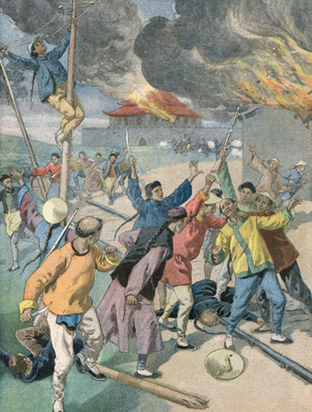
That monopoly was severely tested by the Russian Revolution of 1905. Peasants and workers, along with discontented members of the middle and upper classes, tried to topple a weak and incompetent czar. More political reforms followed, but the basic power structure remained unchanged.
China In the mid-1800s, China tried to limit its trade with the West. Yet China was weak. Western powers used their military superiority to force China to trade more openly. In 1895, as a result of war with a resurgent Japan, China lost control of Korea. Japan also extracted economic concessions from China. Western powers took this opportunity to seize strategic ports and other territory. The carving up of China had begun.
Foreign bullying of China helped create nationalist feelings among the Chinese. They wanted the foreigners out of their country. That came to include the ruling Qing (ching) dynasty. The Chinese saw themselves as Han people, or descendants of the Han dynasty. The Qing dynasty, however, was founded by Manchus who had invaded some 250 years earlier. It was easy to blame this alien dynasty for the weakness of the Chinese state.
In addition, strong support existed among urban, educated Chinese for a republican form of government. These and other factors came together to trigger the Chinese Republican Revolution of 1911–1912. The resulting republic, however, would fall victim to internal power struggles and further foreign intervention in the years that followed.
SECTION 4 Industrial Revolution:
Humans settled down as farmers starting around 8,000 B.C.E. That shift to farming is called the First Agricultural Revolution. In the late 1700s C.E., another huge transformation began. Known as the Industrial Revolution, it changed how work was done. In the process it changed entire societies. Until that time farming and manufacturing made use of muscle power. The revolutionary aspect of industrialization was the switch to machine power. Machines did work much more quickly and efficiently than humans or animals.
Early Industry in Britain The Industrial Revolution began in Great Britain in the 1760s. Why there? One of the big reasons was coal. Britain had a lot of this fossil fuel. Coal was crucial to the efficient production of iron and, later, steel. Just as important, coal became the main source of energy used by industry.
Britain also had gifted inventors and bold entrepreneurs. New fiber-spinning and weaving technologies, including the spinning jenny and the water frame, speeded up textile production. Entrepreneurs built bigger textile machines and linked them together in a central location—a factory. They powered the early factories with flowing stream water. The water turned a large wheel, which spun a crankshaft, which activated the machinery. Later another British invention, the steam engine, replaced waterpower in many places.
Indirectly, coal mining had led to the development of the steam engine. Coal mines, dug deep into the ground, tended to fill with water. Pumps powered by steam engines kept the mines from flooding. The first efficient steam engine, designed by James Watt, appeared in the 1760s. By the 1780s, improved models were driving the machinery in textile factories. The steam engine, by putting coal’s potential energy to work, became the key invention of the Industrial Revolution.
Scholars cite several other reasons for Britain’s early industrialization. One is political. Britain’s government was based on liberalism. It gave its citizens the freedom and security to pursue new ways of doing things. It also backed overseas trading ventures. The success of those ventures infused the economy with capital. Capital can be money. It can also take other forms, such as the factories and machinery used to produce goods.
Another reason behind the rise of British industry is rapid population growth, which supplied labor for factories and consumers for factory goods. Yet another is transportation. To ship raw materials and finished goods, Britain built a system of canals and later a network of railroads.
For all its advantages, Britain did not industrialize in isolation. The Industrial Revolution was a global phenomenon. Britain’s interactions with Asia, Africa, and the Americas made its industrialization possible. Take the cotton textile industry, for example. Cotton did not grow in Britain. During this period Britain imported raw cotton from the West Indies, India, and Egypt. But the American South, where enslaved Africans provided the labor, was Britain’s largest supplier by far. By 1800, British merchants had access to overseas markets as far away as China. There they traded their cotton cloth and other machine-made goods for sizable profits.
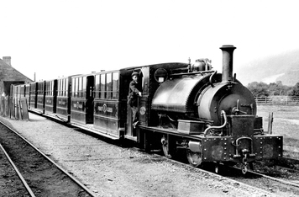
Industrialization Spreads Britain provided the model for how to industrialize. From Britain, industrial technologies and processes spread first, in the 1820s, to northwestern Europe and the northeastern United States. Where coal supplies were limited, as in France and New England, waterpower ran factories. By the 1880s, industrialization had begun in Russia, Japan, and parts of central Europe, as well as in several British colonies.
In 1880, Britain remained the world’s top economic power. By 1900, Britain, Germany, and the United States together produced two-thirds of all the world’s manufactured goods. On the eve of World War I, in 1914, the United States had developed into the world’s leading industrial power, followed by Germany and Britain.
All three of these countries, as well as France and Japan, built extensive rail networks. Railroads, with their coal-fired steam locomotives, proved to be a key driver of the Industrial Revolution. Their speed made it possible to ship products rapidly and cheaply over long distances.
This helped companies develop a national market for their manufactured goods. Railroads also helped factories grow. Factory managers could rely on railroads to deliver equipment and supplies in a timely manner. Railroads themselves consumed great amounts of coal and steel, thus helping those industries thrive. They also employed huge numbers of workers. In addition, the enormous amounts of capital needed to start and maintain a railroad encouraged innovations in financing and promoted the rise of big business.
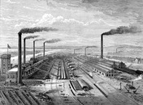
Industrial Capitalism In the era leading up to the Industrial Revolution, European merchants prospered. They oversaw the manufacture, by hand, of a variety of goods. They traded those goods throughout the world. Over the years these merchants amassed the business skills and the capital needed to support the rise of industry. Some searched for new and more efficient ways to make products—and profit. In the process these merchant capitalists became industrial capitalists.
For industry to flourish, societies needed a means of concentrating large amounts of capital. Early in the period, the joint-stock company served this purpose. It raised capital by selling stock, or shares of ownership in the company. Since the 16th century, these companies had been involved in trade. Now they began to appear in industries such as mining and railroads.
In a joint-stock company investors held the stock jointly. All investors shared the profits—and any losses. In fact, if a joint-stock company went bankrupt, any of the investors could be forced by law to cover its debts. To encourage investment, states began passing laws limiting investors’ liability, or legal responsibility. Thus, in the mid-1800s, a new and robust business form, the corporation, was born. This innovation spread quickly through Europe and became a cornerstone of capitalism.
Capitalism has a variety of meanings. Basically, it is an economic system in which all resources are privately owned. Markets determine how those resources are distributed. Modern capitalism arose with industry. In a strictly industrial context, the meaning might focus on owners and workers. It can be viewed as a system in which a fairly small number of capitalists own the means of production—such as the factories and equipment. They employ a much larger number of wage laborers to produce goods. The employers, or owners, sell the goods and reap the profits.
Economic inequality between the owning class and the working class appeared to be a built-in aspect of capitalism. Some people argued that the great wealth generated by the Industrial Revolution should be shared by all members of society. This theory, known as socialism, aimed to replace private ownership of the means of production with public ownership. The German philosopher Karl Marx explored the historical struggle between the social classes. Marx denounced capitalism and predicted that a worker revolution would one day replace it with a classless, socialist system.
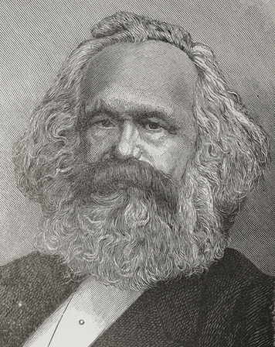
Industrial laborers were often poorly paid and forced to work long hours in unhealthful, dangerous conditions. Yet, in general, they preferred reform to revolution. They joined political parties that campaigned for social improvements. They also banded together to form labor unions. Labor unions sought to improve workers’ wages and working conditions. Yet the world’s workers never rose up against the capitalist system as Marx had predicted.
Consequences for Societies Worldwide Wherever industrialization took hold, economies grew. New technologies and methods greatly increased productivity and lowered costs. Societies, too, changed in fundamental ways. The Industrial Revolution—over time—transformed how people worked, where they worked, where they lived, and more.
Traditionally, manufacturing took place in home workshops. Rural households—men, women, and children—worked together to spin thread, weave cloth, and make tools and other goods. Merchants provided raw materials to these skilled artisans and paid them for their work. This “domestic system” declined with the rise of industry.
Industrialists completely changed the method of organizing production. They gathered their workers together in factories. Workers, and machinery, had to be near the power source—flowing water or steam engine. They also increased specialization. Jobs that one person had handled in a home or shop were now subdivided into multiple tasks.
This improved efficiency but made the work more boring. It also took much of the skill out of the work. Instead of weaving fabric by hand on a loom, textile factory workers merely tended their machine. Unless there was a breakdown, they never even had to touch the cloth. Industrialization also took some of the pleasure out of work. There was little time to relax or daydream in a fast-paced factory.
In the early years of the Industrial Revolution, women regularly worked in light industries such as textiles. In Western countries, however, many were later displaced from their manufacturing jobs in favor of men. They often ended up taking in laundry at home or working as domestic servants. However, in countries such as Russia and Japan, which industrialized later, the need for cheap labor meant that women filled the factories.
Children had always worked, especially on the farm. At first, few people took issue with child labor in factories. Children were expected to help support their family. Owners hired them in part because they worked for less pay than adults. Also, their size was a benefit. It allowed them to slip inside a power loom to fix a broken thread while the machine was still running. It also made it easier for them to work in the narrow tunnels of coal mines. As the 1800s progressed, reformers began to push for laws limiting child labor. By 1900, in the West and in Japan, education had become most children’s main occupation.
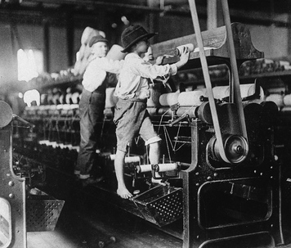
During this time, agriculture made greater use of factory-made tools and machinery. As a result, fewer workers were needed to produce food. Industrialization thus encouraged mass migration “from field to factory.” The jobs were in the factory towns. The Industrial Revolution also boosted global migration, as people moved to countries with growing industries. Urbanization increased, as factory towns quickly grew into cities.
Factories ran mainly on coal. The environmental consequences of the burning of coal included heavily polluted air. Waste from factories fouled nearby waters as well. Charles Dickens described the atmosphere of a mid-1800s English factory town this way:
It was a town of machinery and tall chimneys, out of which interminable serpents of smoke trailed themselves forever and ever, and never got uncoiled. It had a black canal in it, and a river that ran purple with ill-smelling dye.
—Charles Dickens, Hard Times, Chapter V

SECTION 5 Imperialism:

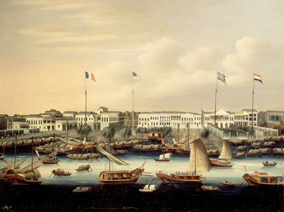
In the late 1800s, several industrialized states expanded their territory. They were by no means the first powerful states to do so. The Roman, Athenian, Ottoman, Gupta, Han, and many other states had all practiced imperialism. They had taken control of land, resources, and peoples beyond their borders. So had Portugal, Spain, Great Britain, France, and the Netherlands starting in the 1500s. During this pre-industrial period, these European powers had ruled the seas. They had conquered and colonized the Americas and had opened coastal trading posts across the rest of the world. Three centuries later, in the midst of the Industrial Revolution, another imperialist expansion began. A slightly different set of global powers hungrily gobbled up territory, mainly in Africa and Asia. The colonies that they established, however, served a different purpose from the earlier ones.
The New Imperialism In the pre-industrial period, European imperialist powers developed a mercantile economic system. They relied on their colonies for slaves, precious metals, and consumer goods such as spices and sugar. Europeans obtained what they wanted by trading with the native peoples or colonists. This old-style colonialism often involved warfare. European powers used force to acquire colonies. They also competed militarily with one another to hold on to their colonies. In time, however, many colonies in the Americas fought to gain their freedom. Their political revolutions curbed the imperial ambitions of European states for a while.
Those ambitions returned full force in the late 1800s. With industrialization in full swing, Western powers scoured the world for raw materials to keep their factories going. They also sought sources of food for the workers who labored in those factories. At the same time, they pursued markets for their machine-made products. New colonies fulfilled some—though by no means all—of those needs.
Times had changed, however. Now, if a colony was unable to supply enough of a resource, the dominant state would often just take over the production process. In this way, Western powers introduced modern industrial practices into their colonies. These colonizers typically extended their dominance beyond the economy, however. They built roads and railways, mines and factories, schools and hospitals. They trained police and set up Western-style legal systems. They imposed their own leaders, language, and culture. In short, they practiced a modern form of imperialism.
Besides their role as a supplier of resources, colonies served other purposes as well. One was strategic. Imperialist powers expanded into places that gave them a geographic or economic edge on their rivals. Britain, for example, had come to rely on India as a market for its textiles. British forces took control of territory along the sea route to India to keep that commerce secure.
Colonies also served as a source of national prestige. By adding territory, a weak government could boost its political standing at home. All in all, the new imperialism served the European states well. By 1914, they would occupy or control most of the world.
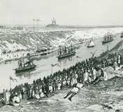
The Scramble for Africa Europeans’ imperialism seemed to contradict their liberalism. It had nothing to do with freedom and equality. One way that they justified imperialism was to argue that it brought progress to so-called “backward” peoples. Europeans argued that they had a moral duty to introduce others to the knowledge, wealth, and Christian values of Western civilization. Many thought that their global dominance could be explained as biological superiority to other races. Scholars have pointed out the racism inherent in such views. The Western attitude toward Africa is a prime example.
Starting in the late 1400s, European states had traded along the African coast, mainly for slaves. By the late 1800s, nearly all of the world’s major states had abolished slavery. The coastal trade with Africa had largely vanished, although Africans themselves continued to practice slavery.
European interest in Africa was rekindled in 1869, with the opening of the Suez Canal. This waterway through Egypt linked the Mediterranean and Red seas. It greatly cut the travel time between Britain and India. When a rebellion in Egypt threatened to close the canal in 1881, Britain occupied the country. This action unleashed a “scramble for Africa.” The major European powers all began claiming territory in Africa.
When the dust settled, nearly the entire continent was in European hands. The British held on to Egypt and took much of the rest of northeast Africa. They also controlled lands from South Africa north to Rhodesia. The French occupied nearly all of West Africa. Germany, Italy, and Portugal each grabbed several sizable chunks of territory. Spain claimed smaller areas on the western coast. The scramble left Belgium with just one region along the Congo River basin in the center of the continent. But that region was huge. Its mineral wealth would make it one of the few African possessions that yielded a profit.
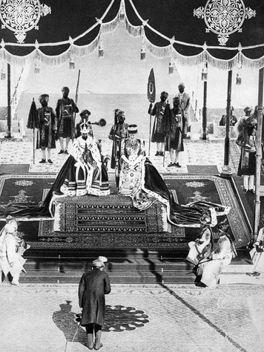
Imperial Powers in Asia Since the early 1600s, the British East India Company had been acquiring territory in India. When the government took charge of the colony, in 1858, all of India came under British rule. There the modernizing effect of imperialism was clear. The British introduced new technology and greatly expanded access to education. At the same time, it exploited India’s people and resources for its own benefit. Karl Marx noted the paradox in British imperial policy. He wrote:
England has to fulfill a double mission in India: one destructive, the other regenerating—the annihilation of old Asiatic society, and the laying of the material foundations of Western society in Asia.
—Karl Marx, “The Future Results of the British Rule in India,” 1853
From India, Britain extended its control westward into Persia. There it competed for dominance with Russia, which had steadily expanded southward through Central Asia during the 1800s. Russia also looked eastward, toward an ever-weakening China. In 1891, Russia began building its Trans-Siberian Railroad. It would run from Moscow east to the Pacific coast. The Chinese conceded, or granted, to Russia an area of land in Manchuria for its railway. This concession gave Russia control of that chunk of northern China.
Of all the lands on the Asian continent, the greatest object of imperial interest was China. Starting in the mid-1800s, Britain, France, and Germany competed for access to China’s markets and its huge population of consumers. These Western powers all demanded, and obtained, more open trade.
Then, in the 1890s, Japan entered the competition. Its Meiji government had transformed and strengthened its economy and military and was ready to expand. In 1894, Japan and China went to war over control of the Korean peninsula. The Japanese won. Their victory encouraged the Western powers to demand even more concessions from China.
China had traditionally exerted its influence over much of Southeast Asia. But Western powers had long challenged China in the region. By 1890, the French had conquered Indochina and the British held Burma, Singapore, and parts of Malaya. To the east, in the Pacific Ocean, Western powers annexed many islands. Britain, Germany, and a new imperialist power—the United States—vied for control of strategic island ports.

