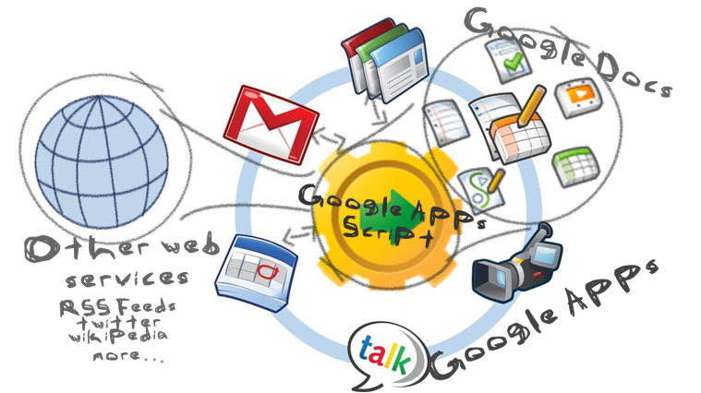

Welcome to the AVUHSD Google Apps
All AVUHSD Teachers and students now have Google APPS.

SO HOW DO WE GET ACCESS??
A few simple instructions and you’re up and running.
STUDENTS
- Find a computer or a device that will allow you to get on the Internet, and go to http://gapps.avhsd.org
- If you’re a student, find the student portion of Gapps and select email.
  - You will be prompted to put in your Username and Password
    - We made this so simple for you– Your username is your StudentNumber.
    - Password. We gave you a temporary password; it is
first initial + last initial + student number (something like this ds123456 all lower case). You will be asked to change it.
USE A PASSWORD THAT YOU WILL REMEMBER
Congratulations your setup is complete!
Your district email address is your student number: number@students.avhsd.org. This is your official email address that will be used by your teachers and staff. Be sure to check your account regularly.
TEACHERS
Your setup is even easier. If you have not already setup your account, you will receive an email with a direct link to setup your account. Simple! If you did not setup your account the first time, contact your site Network tech and have them resend the link.

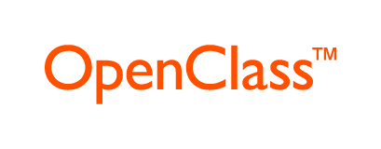
The District’s Learning Management System
“How do I get it?”
Every teacher and student in the district has an account in OpenClass. Teachers will receive a link via their district email accounts and students to their district Google email accounts from OpenClass. You HAVE TO click on the link to setup your account. This link will only work the first the time you select it. You have 45 days from the day you receive the email to activate your account. Check your emails the first week of August.
“What is it?”
It is a course shell you can develop, to upload lessons, pics, videos, begin discussion assign, homework and whatever cool stuff you can come up with. Your students will be able to access via the internet, using any mobile device, or computer that has internet access. And Yes! There is an app for it!
This is the platform we are using to deliver lessons for a flipped classroom.
“Where do I find it?”
Sometime in the fall, there will be a link within both the Teacher and Student portals. Until that setup is finalized, go to:
http://pearsonopenclass.com
“Is it easy to use?”
If you have used a previous LMS such as BlackBoard, Moodle or Edmodo, you will easily be able to find your way around. Every teacher will be enrolled in the OpenClass Orientation class, a self-paced course that will give you a good jump start. There are also Professional Development classes scheduled. (These fill up faster than we can get them scheduled).

