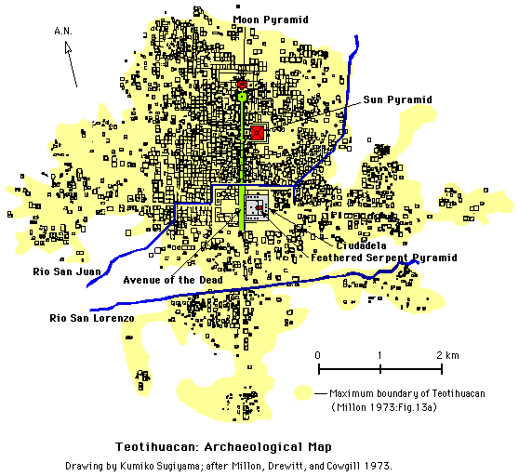

1. List everything you know of can infer from the map. (what do you see? what don't you see? structures? patterns? etc.)
2. What conclusions can you draw from you list?
3. What looks similar to modern cities?

